**LAB 8**

# Question 1:

**Implement 4x1 mux using one 2x4 decoder, four ANDs and one OR gate.**

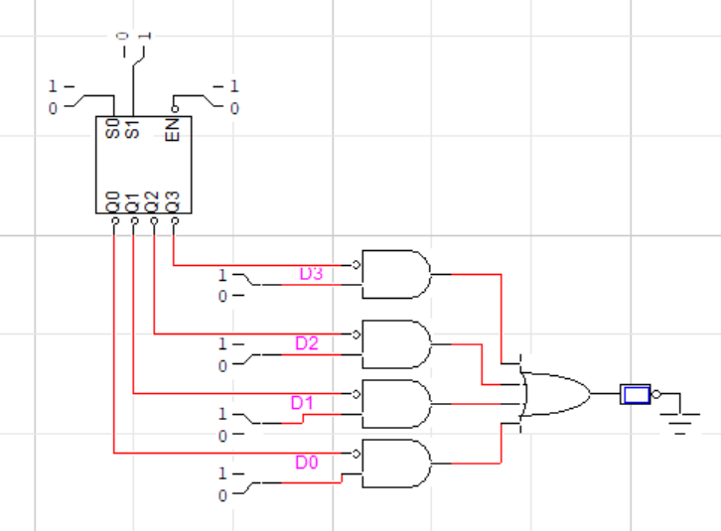

# Question 2:

**Implement the following function using 4x1 mux**

**F (X, Y, Z) = m1 + m2 + m6 + m7**

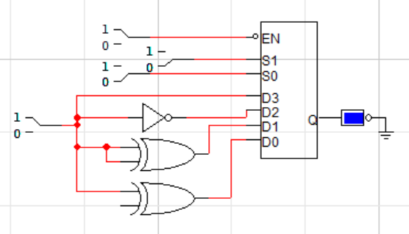

# Question 3:

**Design a circuit that takes two 2–bit numbers and outputs their product.**

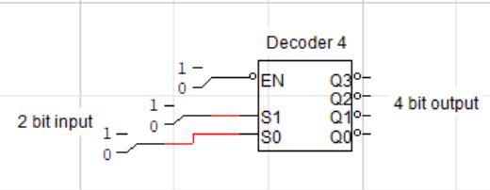

**POST LAB**

# Question 4:

**Implement Dual 2x1 MUX Using 2x1 MUX(s) only**

